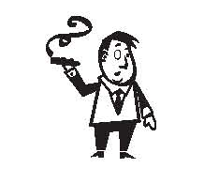

**Pain Explanation and Treatment Diagram**

Hillel M. Finestone, MD, FRCPC

Physical Medicine and Rehabilitation

University of Ottawa

**Ergonomics**

**Name:**

**Date:**

**Chart No.:**

**Exercise**

**Sleep**

**Habits**

Diet

Smoking

Alcohol

**Treatment**

1.

2.

**What are Your**

**“Pain Risk Factors”?**

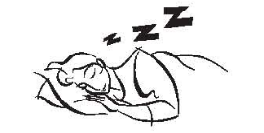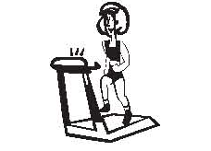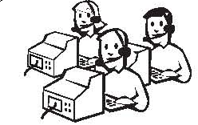

“Machine–body connection”

Poor

Not enough

1.

2.

Not refreshing

Too much

Good

Just right

**Treatment**

1.

2.

**Treatment**

1.

2.

**Treatment**

1.

2.

**Other things that can affect,**

**Diagnosis**

**What I DO think your problem(s) is/are: What I DON’T think your problem(s) is/are:**

1. Bones

2. Nerves

3. Joints

4.

**worsen or aggravate painful**

**conditions — in anyone:**

1. Life in general
2. Financial problems
3. Stress/anger/fear/nightmares
4. History of physical abuse
5. History of sexual abuse
6. Alcoholism (you or your family)

7.

8. **How can stress affect, worsen, aggravate or cause pain? What is the “mind–body**

**connection”?**

1. Adrenaline is squeezed into your bloodstream, your heart rate increases, your muscles

**Treatment** tense up, and you sweat more. Your pain then increases and becomes more intense.

1. 2. When you are injured, any stress that you feel can make the injury and pain worse.

2. 3. Relieving stress may relieve pain.